**DIO Suppression Attack in RPL**

**Software**: NetSim Standard v 14.1, Visual Studio 2022, MATLAB R2019 or higher

**Project Download Link:**

Follow the instructions specified in the following link to download and setup the Project in NetSim:

[https://support.tetcos.com/en/support/solutions/articles/14000128666-downloading-and-setting-up-netsim-file-exchange-projects](https://support.tetcos.com/support/solutions/articles/14000128666-downloading-and-setting-up-netsim-file-exchange-projects)

**Introduction**

In DIO Suppression Attack, a malicious node broadcast DIO message to legitimate nodes. If malicious node transmits repeatedly a DIO message that is considered consistent by the receiving nodes. If the nodes receive enough consistent DIOs, they will suppress their own DIO transmission. Since DIO messages are exploited to discover neighbours and the network topology, their continuous suppression can cause some nodes to remain hidden and some routes to remain undiscovered. DIO Suppression attacks affect the performance of IoT networks protocols such as RPL protocol.

**Real world context**

This smart agriculture network consists of wireless sensors placed across a vast field. These sensors communicate with a Low-Power Wireless Personal Area Network (LoWPAN) gateway to facilitate data transmission between the sensors and a server.

In this network, a malicious node has been introduced, strategically positioned to intercept and manipulate communication. This node is programmed to repetitively broadcast deceptive DIO (DODAG Information Object) messages, aiming to disrupt the RPL (Routing Protocol for Low-Power and Lossy Networks) functionality through a DIO suppression attack.

As the legitimate sensors attempt to organize themselves into an optimized DODAG structure for efficient data routing, the malicious node continuously injects false DIO messages into the network. These deceitful messages can mislead the sensors about the actual network topology

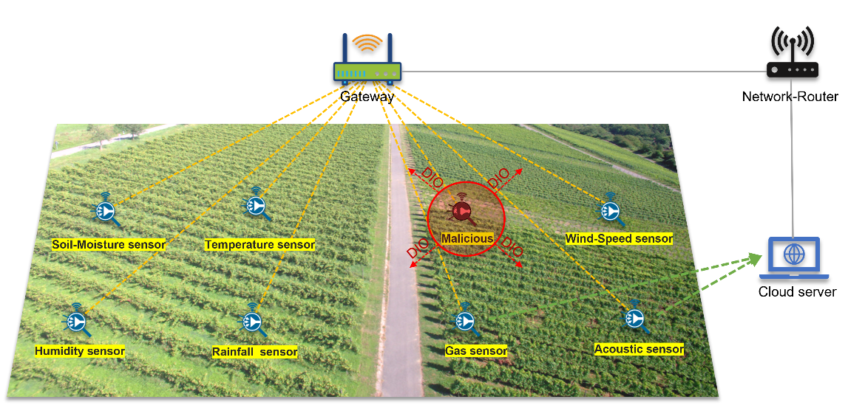

Figure 1 **:** Smart Agricultural Network

**DIO Suppression Attack in RPL Overview**

* Malicious node executes DIO Suppression Attack by repeatedly broadcasting deceptive DIO messages.
* Consistent reception of malicious DIOs leads legitimate nodes to suppress their own DIO transmissions.
* Continuous suppression of DIO messages disrupts the discovery of neighbors and network topology.
* Impacts include hidden nodes and undiscovered routes, affecting the performance of IoT protocols like RPL.

**The Role of NetSim Simulator**

In NetSim we can simulate Smart Agricultural Network with wireless sensors, a LoWPAN gateway, routers, and a wired node also, NetSim can interface seamlessly with MATLAB, providing real-time visualizations of the DODAG formation during the simulation. This integration enhances the educational and research aspects, allowing users to analyse the impact of the attack on network efficiency. NetSim serves as a comprehensive tool for studying IoT network dynamics and security challenges in a controlled virtual environment.

## **Implementation in RPL (for 1 sink)**

* In RPL the transmitter broadcasts the DIO during DODAG formation.
* The receiver on receiving the DIO from the transmitter updates its parent list, sibling list, rank and sends a DAO message with route information.
* Malicious node upon receiving the DIO message it transmits DIO message repeatedly to legitimate nodes.
* The legitimate nodes on listening to the malicious node DIO message they will suppress their own DIO transmission.
* The continuous suppression can cause some nodes to remain hidden and some routes to remain undiscovered.

**The DIO.c file contains the following functions**

1. **fn_NetSim_RPL_MaliciousNode();** //This function is used to identify whether a current device is malicious or not in-order to establish malicious behaviour.
2. **fn_NetSim_RPL_MaliciousNodeReplay();** //This function is used by the malicious node to transmit DIO message repeatedly to legitimate nodes.

You can set any device as malicious, and you can have more than one malicious node in a scenario. Device id’s of malicious nodes can be set inside the **fn_NetSim_RPL_MaliciousNode()** function.

**With-DIO Suppression Attack**

1. The Workspace **DIO_Suppression_Attack_using_RPL_v14** comes with a sample network configuration that is already saved.
2. Go to Your Work option in NetSim Home Screen and open the saved example, **DIO_Suppression_Attack_Example**. The network scenario and the settings done is explained below:

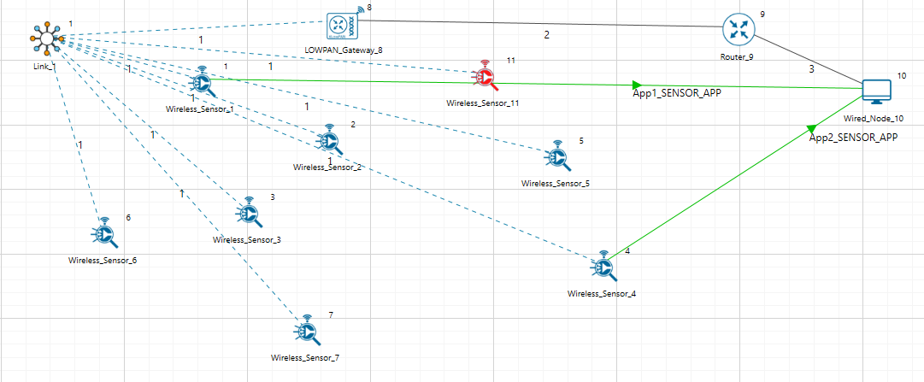

Figure 2**:** Network topology in this Project

**Note:** In above screenshot Red color Wireless_Sensor_Node_11 is a malicious node.

|  |  |
| --- | --- |
| **Application 1** | |
| Source | DEVICE ID 1 |
| Destination | DEVICE ID 10 |
| Packet Size | 50 Bytes |
| Inter Arrival Time | 1000000 μs |
| Packet Size |  |
| **Application 2** | |
| Source | DEVICE ID 4 |
| Destination | DEVICE ID 10 |
| Packet Size | 50 Bytes |
| Inter Arrival Time | 1000000 μs |
| **Link Properties (Adhoc Link 1)** | |
| Channel Characteristics | Pathloss Only |
| Pathloss Model | LOG DISTANCE |
| Pathloss Exponent | 2.5 |

Table 1: Application and Link Properties

1. Go to LOWPAN Gateway Properties >Network Layer > RPL >DIO Redundancy Constant > 6.

Figure 3 **:** Lowpan-Gateway-Properties

* The DIO suppression attack requires the adversary to transmit only DIO Redundancy Constant(k) messages at each Trickle period.
* DIO Redundancy Constant(k) acts as suppression threshold, as we set 6, the malicious node will replay the DIO message 6 times to the neighbouring nodes. After replaying the DIO message, the neighbouring nodes will suppress their own DIO transmission.

1. Run simulation and press any key to continue
2. It will open MatlabInterface.exe console window. You will observe that as the simulation starts in NetSim, MATLAB gets initialized and the DODAG plot associated with the IoT network is plotted during runtime.

**Without-DIO Suppression Attack**

* To run simulations without DIO Suppression attack open the Source Code click on **Your Work > Source Code > Open Code**
* In **RPL project,** open **RPL.h** and set the value of the variable DIO_ATTACK_ENABLE to 0 instead of 1.
* Rebuild the RPL Project and run Simulation.

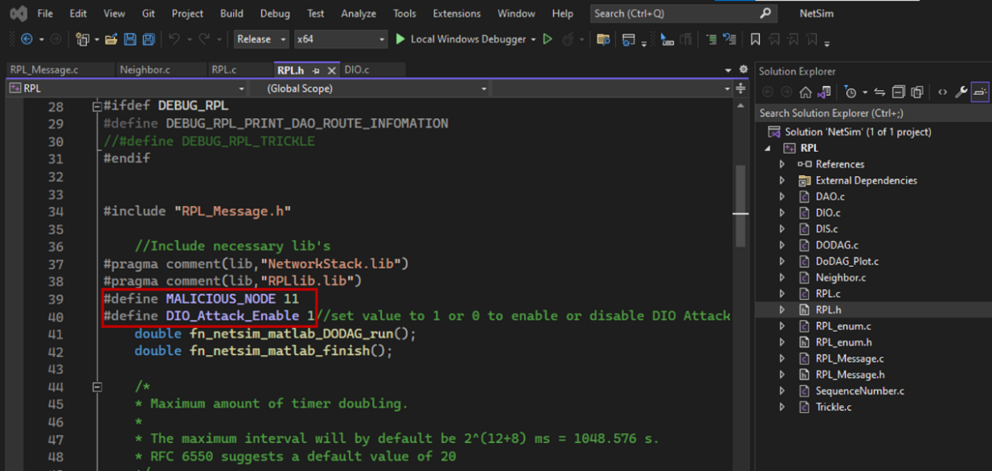

Figure 4: NetSim Project source code in Visual studio, DIO_Attack_Enable set to 1 and to disable set 0

**Results and discussion**

### **Case 1: With DIO Suppression Attack**

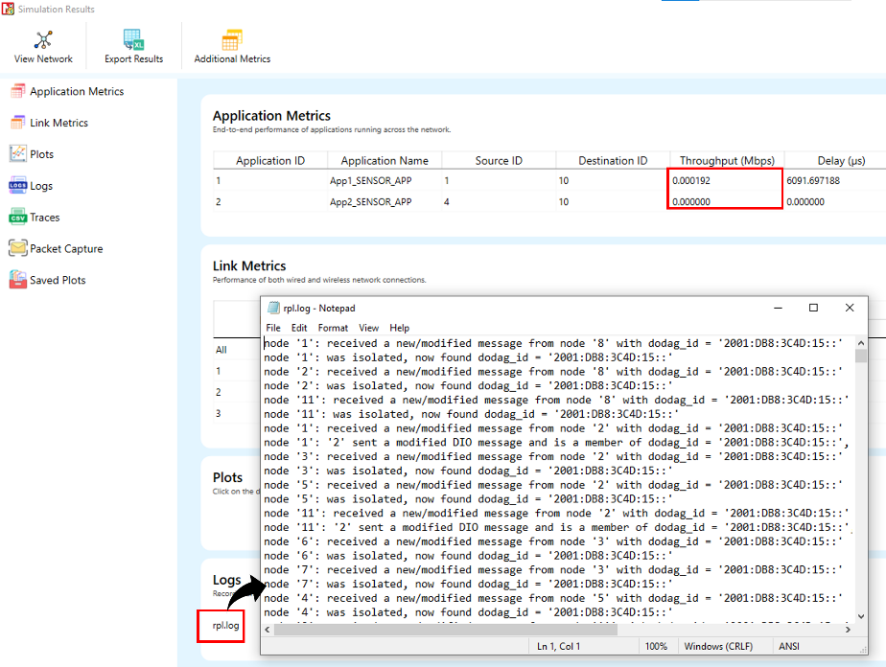

Figure 5: NetSim results dashboard with throughput highlighted

The result dashboard provides access to the RPL log file, Where we can see the detailed information about the DODAG formation process.

**DODAG Formation Graph**:

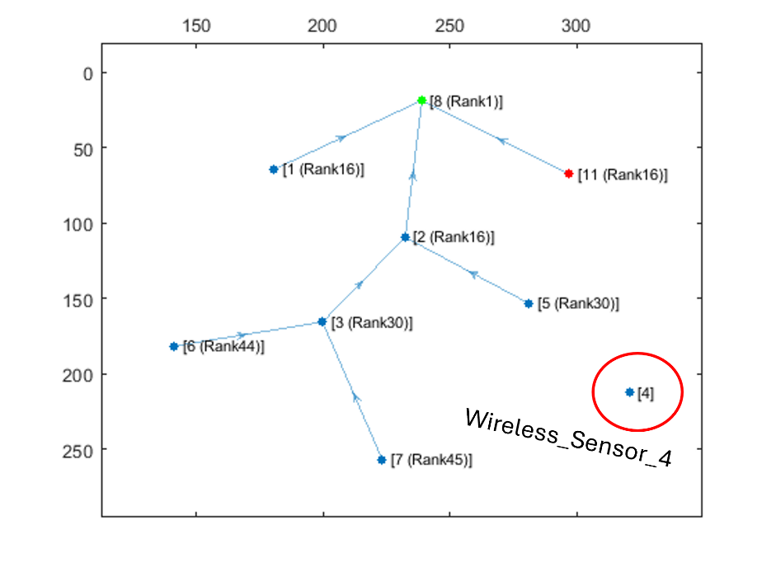

Figure 6**:** DODAG Formation Graph from MATLAB

When root node (LowPan_Gateway) broadcast the DIO message all nodes that are present in the communication range will also broadcast their own DIO messages but when malicious node broadcasts the DIO message, it will repeatedly transmit the DIO message to the neighbour nodes such that it prevents the DIO messages from other neighbour nodes reaching them.

So, it degrades the routing information, and some nodes remain hidden in the network.

We can observe from the above graph that **Wireless_Sensor_4** is not part of DODAG formation as it is not discovered and remain hidden in the network.

### **Case 2: Without DIO Suppression Attack**

Figure 7**:** NetSim results dashboard

**DODAG Formation Graph:**

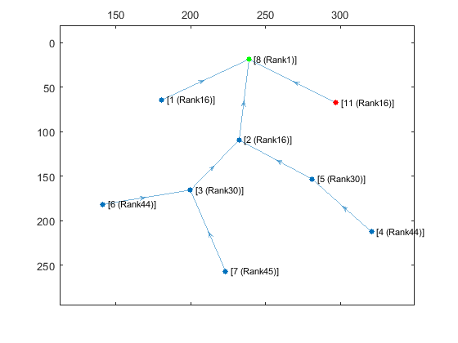

Figure 8**:** DODAG Formation Graph from MATLAB

We can observe from the graph that when the DIO Attack is disabled, The DODAG formation will happen with all the nodes being a part of it

With the DIO Suppression Attack disabled the performance of the network will increase in comparison with **Case 1** i.e., DIO Attack Enabled.

### **Case 3: With DIO Suppression Attack (DIO-Redundancy Constant = 7)**

Figure 9: NetSim Results Dashboard Window

**DODAG Formation Graph:**

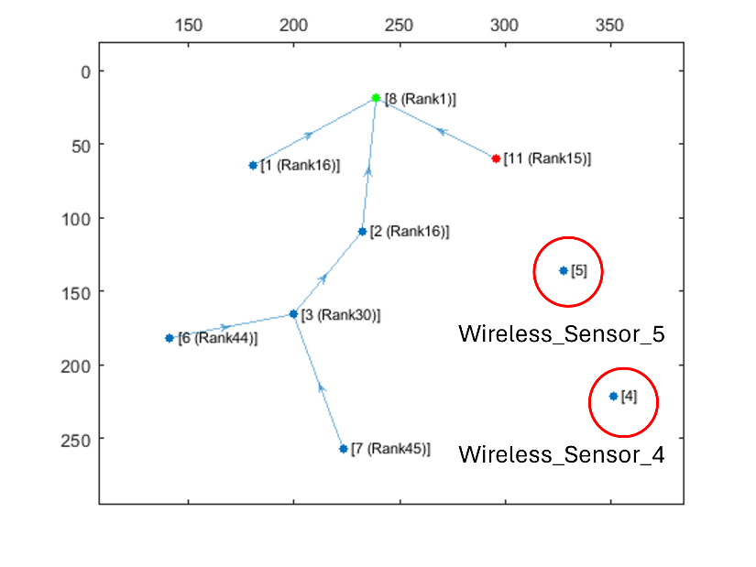

Figure 10:DODAG Formation Graph from MATLAB With DIORedundancyConstant is set to 7

**Note :** To set DIO-Redundancy Constant to 7 you can refer **Figure 3**

We can observe from the graph that Wireless_Sensor_3 and Wireless_Sensor_Node_4 is not part of DODAG formation as it is not discovered and remain hidden in the network.And from the Simulation result dashboard that when we enable DIO Suppression attack in that situation some nodes are hidden due to which our throughput is getting decreased.

DIO Suppression severely degrade the performance of Low Power and Lossy Network (LLNs) because of the repeatedly transmitting the DIO message by the malicious node to neighbouring nodes.

The DIO suppression attack, an attack that induces victim nodes to suppress the transmission of DIO messages. This causes a general degradation of the routes quality that can lead, eventually, to network partitions.

With the DIO Redundancy Constant set to 7 the Suppression is more than that of the DIO Redundancy constant 6.

## **Appendix: NetSim source code modifications and steps.**

1. Add the following MATLAB install directory path in the Environment PATH variable

<MATLAB_INSTALL_DIRECTORY>\bin\win64

For eg: C:\Program Files\MATLAB\R2021b\bin\win64

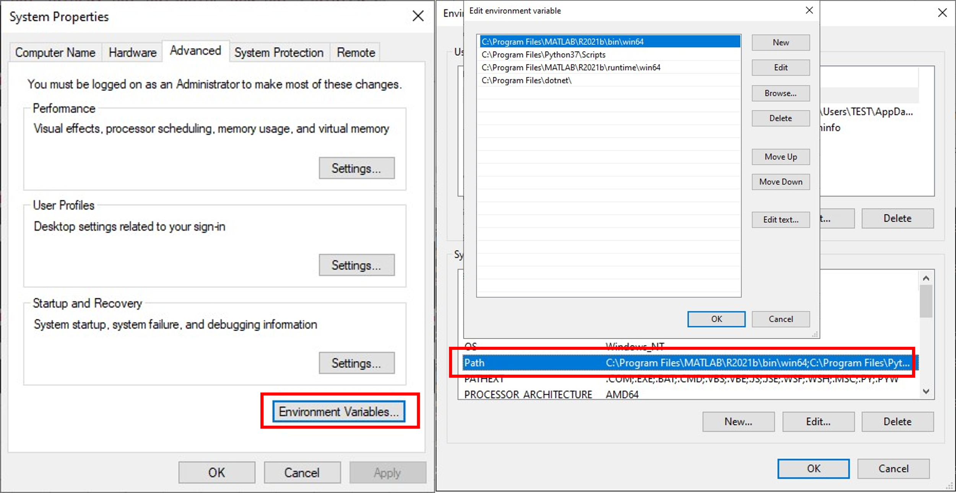

Figure 11: Set environment variable path

**Note:** If the machine has more than one MATLAB installed, the directory for the target platform must be ahead of any other MATLAB directory (for instance, when compiling a 64-bit application, the directory in the MATLAB 64-bit installation must be the first one on the PATH).

1. Open Command prompt as admin and execute the command “matlab -regserver”. This will register MATLAB as a COM automation server and is required for NetSim to start MATLAB automation server during runtime.
2. Go to home page, Click on Your work>Source Code and click on the Open code button.
3. Set malicious node id in RPL.h file.

#define MALICIOUS NODE 9

**The section of code that is highlighted in red color is added to the RPL_Message.c file under rpl_process_ctrl_msg() function.**

void rpl_process_ctrl_msg()

{

switch (pstruEventDetails->pPacket->nControlDataType % 100)

{

case DODAG_Information_Object:

#if DIO_Attack_Enable

if (fn_NetSim_RPL_MaliciousNode(pstruEventDetails)) {

rpl_process_dio_msg();

Fn_NetSim_RPL_MaliciousNodeReplay(pstruEventDetails);

}

else

rpl_process_dio_msg();

#else

rpl_process_dio_msg();

#endif

break;

case Destination_Advertisement_Object:

rpl_process_dao_msg();

break;

case DODAG_Information_Solicitation:

rpl_process_dis_msg();

break;

default:

fnNetSimError("Unknown rpl ctrl msg %d in %s",

pstruEventDetails->pPacket->nControlDataType,

__FUNCTION__);

break;

}

1. Now right click on Solution explorer and select Rebuild.
2. Upon rebuilding, libRPL.dll will automatically get replaced in the respective bin folders of the current workspace.
3. Then run the Example scenario which came along with the Workspace.